CLAG Research Award: Report
Nicholas Kotlinski
University of Kansas

My fieldwork took place from mid-June through early August in the Upper Peruvian Amazon. I specifically focused on the departments of San Martin and Loreto, travelling throughout the region while basing myself in urban hubs to stay in contact with friends, contacts, and informants. Research funds were used to pay for local transportation, lodging, research assistance, and a cell phone for easier communication.

The main focus of my fieldwork was in the provincial capital of Barranquita. This small cattle town is situated in the Cainarachi Valley, and is located 28 kilometers up an unpaved artery off of the marginal highway that connects the high jungle metropolis of Tarapoto to the lowland river port of Yurimaguas. Barranquita was selected for my study entitled, “Oil Palm Development in the Peruvian Amazon: Reading Conflicting Views”, because it has served as a nexus for the growth of oil palm production as well as resistance in the name of land and environmental rights.

After a short stop in Yurimaguas visiting friends, drumming up informants, and traveling to chacras (farm plots) in the vicinity, I made my way to Barranquita. I was accompanied by three generations of Barranquita-Yurimaguas residents who split their time between urban and rural life. The eldest was returning to Barranquita to tend his chacra while the two female companions came (thanks in part to research funds) to visit family members who could facilitate my research and provide contacts in the community.

While in Barranquita I was introduced to community members, chacreros (small-scale farmers) and activists who would inform the core of my study. I used surveys and semi-structured interviews with farmers, along with informal conversations and observations with community members over dinner and tragos (often my only way to gather the opinions of women on politics and land conflict in the region) to understand some of the nuances of local life and issues ranging from health, local politics, and migration. Along
with qualitative methods, I accompanied farmers to their land to carry out transect walks
using GPS to map the extent of individual small-holder plots and, if present, their plantings of oil palm.

The study investigated the broad question: what is the “on the ground” (as opposed to environmentalist or industry produced) reality of oil palm cultivation? By searching for common “archetypes” in land conflict studies, I was able to view oil palm development through different levels of involvement, which included: protestor/resistor, transitional (small-scale/multi-cropping), and fully integrated (small-scale/mono-cropping). I collected spatial data related to all three archetypes, giving a quantitative land-use value to small-holder oil palm production and land-use transition in the region.

Qualitative data from the first two archetypes offered insights into the role of environmental consciousness and forest conservation, but also the role of community activism in response to the establishment of large-scale oil palm plantations. One “transitional” farmer provided an interesting case in which his participation in protests against the establishment of a large-scale oil palm plantation in the past did not dissuade his current participation in the oil palm economy. He had recently started planting and selling harvested palm kernel to the same company in control of the plantation. Furthermore, the company, according to informal conversations, was continuing to buy land through intermediaries or control land by promoting the planting of alternative (read as alternatives to coca) cash crops.

I interacted with and interviewed local “protest leaders” at a well-known regional parochial radio station located in the community to discuss their activist work and past organizing against large-scale oil palm development. In addition, we discussed their current work disseminating information on land rights, environmental issues, and promoting environmental youth groups in the area.

Although highly productive, my field stay was cut short after one of my field companions fell ill and we were forced to return to Yurimaguas ahead of schedule to seek medical attention. A second trip was planned to accompany community activists to untitled indigenous communities that were heavily involved in protests and affected by the plantation development, but this work could not be undertaken due to illness and time constraints.

Award monies from CLAG also allowed me to take part in a week long participatory mapping project in the native community of Alto Huaja – or the locally preferred Kechwa name, Yaku shutuna rumy – in the province of El Dorado (San Martin). This experience allowed me to witness firsthand the process of native community titling while supporting regional NGOs in their work with communities engaged in participatory mapping. While my work on the mapping project shifted attention away from my main field site, the connections made with regional NGOs and staff, along with conversations with community members, led to insights into my larger project and solidified future research contacts.

My current focus is on coding land use related to GPS points taken in the field to incorporate into GIS and remote sensing work. I am also in the tedious process of transcribing and coding recorded interviews and field notes.

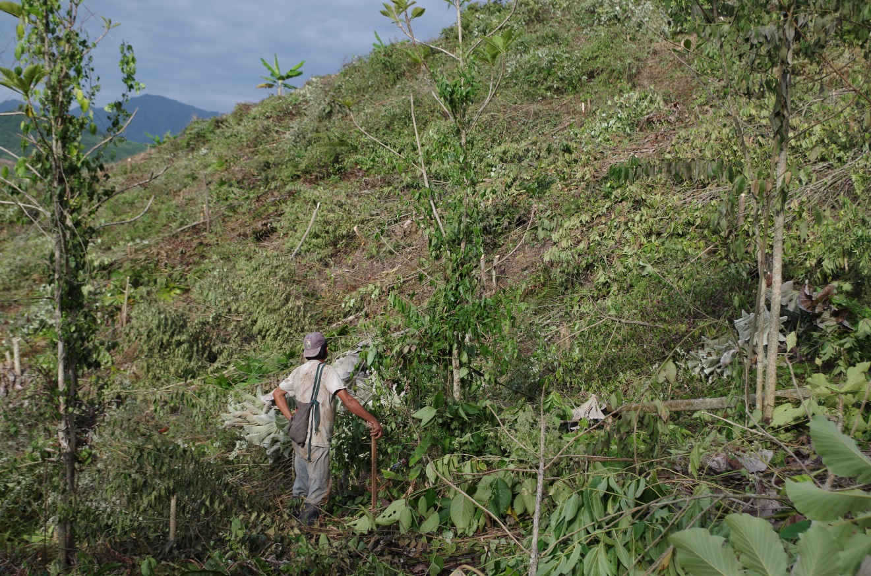

The apu (elected leader) of Alto Huaja surveys a recently cleared hillside while selectively logging remaining trees for a home construction project. The steep forested hills of El Dorado province (San Martin) are cleared for plantings of corn and plantains. After harvest these hills are allowed years of rest to revert to forest before starting the process again.

