Final Report to CLAG: Chronic Kidney Disease in Central America

Purpose and Goals of Travel: In the past three decades, a “new” form of Chronic Kidney Disease has unfolded into an epidemic across lowland pockets of rural Central America, claiming upwards of 20,000 lives. Though the cause from a medical perspective is still very much debated, environmental and/or occupational exposure to agro-chemicals, possibly in combination with repeated dehydration, are the leading hypotheses. The purpose of my summer field research in El Salvador and Nicaragua was to explore the ways in which narratives about the disease are unfolding alongside the epidemic’s environmental and medical realities. More specifically, I spent the summer attempting to understand how individuals and communities are experiencing the disease, and how these local actors are interacting with – be it internalizing, responding to, or challenging – broader national and regional discourses about kidney disease.
Description of Activities: In my original proposal, I outlined a comparative project in which I would split my summer half-and-half between Nicaragua and El Salvador, the two countries most affected by and active in responding to the kidney disease. Due to practical complications, I ended up spending 9 weeks in El Salvador and only 1 week in Nicaragua, without changing the larger goals of the project nor my methods and NGO contacts on the ground. In the end, doing so allowed me to develop a much deeper understanding of the Salvadorian situation than I would have otherwise. Yet the information I collected in Nicaragua deeply informed my understanding of the Salvadorian situation and shaped the questions I brought to my fieldwork there. As the response to kidney disease in these two countries has differed in many key respects, I will need to reference Nicaragua when writing about El Salvador, and I hope to carry out a more thorough comparison for my PhD.
I started my summer with a week at La Isla Foundation (LIF), based out of León, Nicaragua. As LIF is the only NGO focused solely on researching this emerging epidemic (largely, via public health), spending a week learning about Central American kidney disease from their perspective was the perfect introduction to my fieldwork. While taking refresher Spanish classes, I interviewed LIF staff members, visited a community in the Chinandega Department severely impacted by the disease, and talked with community members.
The rest of my summer was spent based out of the Bajo Lempa region of El Salvador, which is the basin of the Lempa River, and like Chinandega, Nicaragua, is hot, steamy, Pacific lowlands, dominated by sugarcane fields. Yet due to El Salvador’s land reform in the early 1990s, many residents of the Bajo Lempa own their own land parcels, which often border the larger cane fields. These parcels are primarily used for small-scale corn and bean production. Many sugarcane fields are owned by agricultural cooperatives but still sell to big ingenios.
During my 9 weeks in the Bajo Lempa, I was hosted by the local NGO Asociación Mangle, and its partner NGO from the States, EcoViva. I conducted many hours of participant observation at a local government-run health clinic in the community of Ciudad Romero. This clinic was built in 2013 in response to the kidney disease epidemic, and has a specialized staff trained to treat kidney patients, in addition to their general medicine duties. My participant observation included sitting in on meetings and appointments, walking around with health promoters, debriefing with the doctors, and helping to organize the renal patient database. I also conducted semi-structured interviews of varying lengths with patients at the Romero clinic, at satellite clinics served by the Romero staff, and in homes across the Bajo Lempa.
Beyond the clinic, I conducted interviews with policy makers and community members and leaders who have addressed kidney disease through both health and agricultural politics. I interviewed cane cutters, NGO workers, mayors, representatives of agricultural cooperatives, congressional representatives, and environmental health researchers. Some of these interviews involved traveling to San Salvador and other departments beyond the Bajo Lempa.
My award from CLAG funded a portion of my lodging and food costs for the summer as well as a variety of operational expenses. These expenses included a pre-paid cell phone and calls to facilitate fieldwork logistics, a digital voice recorder, and in-country transportation costs.
Results: I found that, as an emerging, high-incidence issue that requires expensive dialysis for end-stage patients, kidney disease is both challenging medical expertise and overwhelming public health systems in El Salvador and Nicaragua. El Salvador, however, has had a unique response. A national ban on 53 agro-chemicals was heavily debated in 2013, although its passage is currently stalled. And since 2009, the Salvadorian Ministry of Health has been constructing new clinical spaces, developing medical guidelines, and sponsoring clinical and environmental research, not to mention spearheading international forums and discussions based on the Salvadorian experience of kidney disease. This response is still unfolding and is currently very uneven in its impact on individual communities. Nationwide, only three hospitals offer dialysis under the free public healthcare system, so transportation costs, in both money and time, drive variability. Factors such as medicine stocks, medical personnel’s familiarity with this new disease, and community health worker programs also vary greatly within the country.
My research also suggested that how the disease is being produced and reproduced in the first place – materially and socially – may be as uneven a process as the medical response towards already-sick patients. The most obvious illustration of this is that most reports coming out of Nicaragua indicate that sugarcane workers (usually young and male) are the primary group getting sick. However, I was surprised to learn upon arriving in El Salvador the extent to which people of any age, gender, or occupation are being affected. Many of my interviewees were small-scale corn farmers or their wives, who had never cut sugarcane (or had done so sporadically in the past) but lived or worked in extremely hot and humid conditions, in close proximity to sugarcane fields, and had applied agro-chemicals to their personal corn fields. Agro-chemical contamination has also been detected in high levels in the soil and groundwater in the region. Such observations complicate the tense debates in the international medical literature that have tried to reduce the epidemic to either an occupational or environmental health issue.
I also learned that the “causes” of the epidemic cannot be extricated from the response or the debates about the appropriate response. For example, kidney disease is theoretically manageable and even reversible if detected early. By changing diets, taking medicines, drinking more water, and avoiding occupational and/or environmental contact with agro-chemicals, one blood test indicating elevated creatinine levels does not have to be a death sentence. Yet far too frequently, it is, and the reasons why are complicated and deserve further exploration. Likewise, how patients internalize or reject medical recommendations to change their individual practices and social interactions are both “causes” of and responses to the epidemic. For example, many corn farmers with advanced kidney failure told me that they pay day laborers to spray their fields with pesticides because a doctor has prohibited them from such activities. Even more told me that they would not get dialysis even if prescribed because doing so would kill them faster. On the other hand, I met farmers who switched to organic, diversified agricultural production upon receiving a kidney disease diagnosis, or became auto-mechanics and taxi drivers. I also met young people who were inspired by the death of a family member or the epidemic’s impact on their community to become agronomists, social workers, and even nephrologists, with hopes of addressing the epidemic.
Appendix - Photos

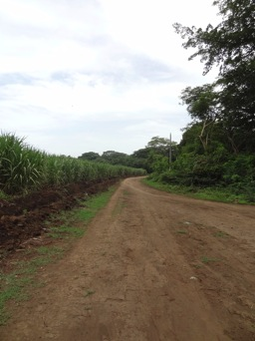
La Isla community, Chinandega, Nicaragua.
Sugarcane fields on the left, edge of community on the right.
Emma Lawlor, June 2014

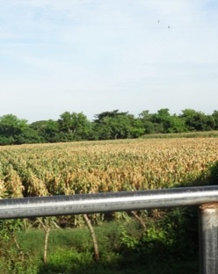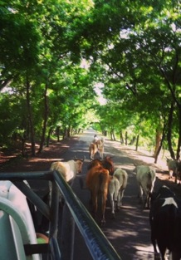
View from the road to Ciudad Romero, Bajo Lempa, El Salvador.
Many farmers lost their summer 2014 corn crop to drought.
Emma Lawlor, July 2014

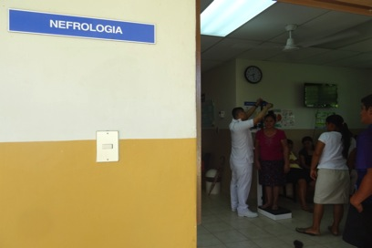
Specialized health clinic in Ciudad Romero, El Salvador.
Nefrology appointment triage.
Emma Lawlor, August 2014

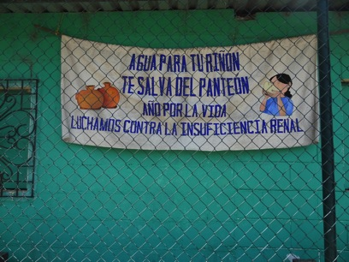
Fondo de Emergencia building, Cantón Zamorán, Bajo Lempa, El Salvador.
A building in the community next to Ciudad Romero.
Emma Lawlor, July 2014

