CLAG Field Report – Noah Silber-Coats

This report describes my fieldwork experience in Veracruz, Mexico during the summer of 2014. My project evolved significantly from the proposal submitted to CLAG, which merits some explanation. Originally, I planned to focus on a rural land use planning tool called ordenamiento ecológico and its relationship to climate change adaptation projects. As it turned out, many of the projects I was interested in looking at were in their early stages and would not have been very fruitful objects of study. However, I did find that ordenamiento was playing an important role in a conflict over dam construction in central Veracruz. Learning about this issue, as well as making contact with some key actors, led me to re-orient my research while still retaining a focus on resource governance.
For reasons which I will explain below, Veracruz is undergoing a highly contested boom in hydropower development. My goal was to understand how the politics and policy of energy, water and the environment interact to shape these conflicts, as well as how they articulate with resource management at the local level.
In order to do this, I focused on developing a case study of one river basin – the Bobos-Nautla – where eight new dams are currently planned. To briefly set the scene, the Sierra of the upper basin is home to campesino communities and a landscape that is a mix of small-scale agriculture (especially coffee and maize) and cloud forest. The steep, wet canyons of this part of the basin are the area targeted for hydropower development. At the foot of the mountains sits the city of Tlapacoyan (pop. ~50,000) where concerns about the impact of dams on domestic water supply have fueled controversy.
Methods
My principal method of data collection was interviews, which covered a range from informal conversations to semi-structured, sit-down interviews with a tape recorder. Interview subjects can be divided into several categories: government officials (federal, state, and local), representatives of NGOs/civil society/social movements, and a category that I will simply call local actors.
Within the government group, I interviewed officials from Conagua (the federal water authority), the Comision Federal de Electricidad (CFE), the state government office in charge of ordenamiento, and representatives from three different municipalities with different perspectives on the projects planned in their jurisdictions. Within the NGO/civil society group I spoke with: representatives of an environmental NGO that is collaborating with hydropower companies, members of a social movement opposing dams, several academics, and a lawyer from an environmental/human rights advocacy group working on a case against several projects. I also accompanied a group of activists on an organizing trip to rural communities near potential dam sites (see photo). Within the local group, many of whom overlap with the social movement, I interviewed a rafting guide, the owner of a river-based tourism company, workers at an existing dam in the basin, and numerous residents from a community adjacent to one proposed project site.
I also collected documents, both contemporary and historical. Documents related to the present situation include environmental impact statements (MIAs) for hydropower projects, contracts for the sale of energy, planning documents related to hydropower in the region, and plans for conservation areas. The historical material, from the Archivo Historico del Agua in Mexico City has to do mainly with failed plans for hydropower projects in the basin dating back to 1898, and conflicts at the time that bear many similarities to the situation that is playing out now. In the following sections, I briefly summarize my findings along the axes of energy, water, environment mentioned above.
Hydropower History
The wave of projects currently planned in the Bobos-Nautla is tied to a 1992 renewable energy law that opened Mexico’s previously state-centered model of river basin development to the private sector for projects that generate under 30 megawatts of energy. These private projects mirror an earlier era at the turn of the 20th century when industrialists built dams to power factories. The current model also allows for industry to generate power for its own use, and mining interests have been particularly keen on taking advantage of this provision of the law.
While the CFE had long-standing interest in building more dams in the Bobos-Nautla, as indicated by their declaration of the basin as a Reserva Nacional de Energia Electrica in the 1950s, it is this re-opening to the private sector that has generated renewed interest in this area.
The relationship between the CFE and private companies is one of both tension and cooperation, and is also shrouded in rumors and intrigue. The CFE engineer that I interviewed lamented that projects they had spent years planning were being “stolen” by private companies, while other informants reported that the CFE was playing an instrumental role in this process.

Water Policy/Rights
The hydropower projects in my case study site raise a number of issues related to water use and policy. Most of the projects use a run-of-river scheme which diverts water from the stream rather than impounding it in a reservoir. This fact is often cited by proponents in asserting that these projects are harmless (“una tecnología muy noble”). However, a number of issues related to conflicts with other water uses remain. Through my interviews with officials at Conagua, I attempted to shed light on the role of the water bureaucracy in making decisions about allocation of water rights in this context. Some of my key findings in this area are that they rely on hydrologic studies provided by the companies which in some cases are based on limited and outdated information. Additionally, the simplification of water rights into a series of points minimizes the effect that the actual infrastructure (including tunnels and canals that stretch for several kilometers) could have on other water users – especially community water sources drawn from seeps and springs downstream of the dams’ diversion point. Finally, although Mexico has recently adopted a policy for maintaining environmental flows, the de facto practice is to allocate up to 90% of a river’s flow to hydropower.

Environmental Regulation and ‘Green’ Hydropower
As mentioned above, one of the key points of contention surrounding hydropower in the Bobos-Nautla has to do with the environmental zoning law known as ordenamiento ecologico. Meant to prevent or resolve conflicts over appropriate use of land and resources in a given area, the ordenamiento actually seems to have fueled conflict in this case. First, shortly before the latest hydropower projects were announced, a detail in the law was changed to allow dam construction in areas zoned for ‘restoration.’ This point has also been used by proponents to argue that these projects are benign or even beneficial for the environment. This ‘greening’ of hydropower is further reinforced by an alliance between an environmental NGO and the company behind several projects to conduct forest restoration in the watershed of the dams.

‘On the Ground’
To briefly summarize what I learned while living in one community where a hydropower project is slated for construction, these projects become enmeshed with local history, politics and daily life in very messy ways. Rumors were rampant about who had been co-opted by la empresa – an almost mythical entity embodied only in the occasional presence of an ‘engineer’ driving an unmarked pickup truck. The specter of this project also seems to be acting as a catalyst in a conflict over the community water supply, as landowners whose property is traversed by the water pipe have sold parts of their land for construction of the dam and access roads.

The funding from the CLAG field award was indispensable in carrying out my fieldwork. In addition to supporting my costs for room, board, and local transportation, I was able to purchase a digital voice recorder for interviews and a camera for documenting the experience.

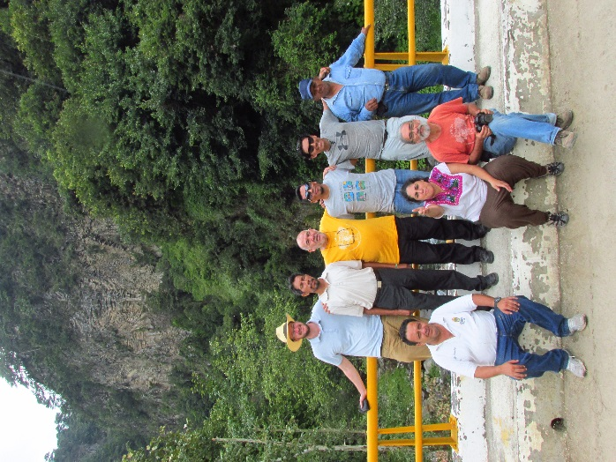
During a visit to the Sierra de las Minas, Veracruz
with anti-dam activists.

