Instructions for registration and payment: CLAG 2015 Fortaleza
Dear CLAG members,
The online registration for the Fortaleza Conference is excruciatingly complicated so that I decided to give you some guidelines. They are not perfect, but I hope they will help you to make your payment.
Type | Registration Fee
CLAG members (Northern Hemisphere and Australia) | R$ 260.00
Non-members (Southern Hemisphere) | R$200.00
Graduate students (both North and South) | R$140.00

Observations:
- Global North researchers pay a higher registration fee (R$260.00 = approx. US$100.00)
- Global North and South graduate students pay the student’s fee: (R$140.00). However, when they register, they need to attach a document proving their status as student (student ID, transcripts etc.).
- Abstract must be submitted till February 10 (send to following e-mail: jorn.seemann@urca.br).
- After the submission of your abstract, I will send you a letter of acceptance in pdf by e-mail (required by Brazilian Consulate in the U.S.).
- There is a possibility to send a complete paper. Deadline: March 31. The Geography Department at UFC publishes the prestigious Mercator journal (A1 category = highest in Brazil) and the GeoSaberes journal.
- Participants who do not present a paper, can register between April 01 and May 26. The fee for this period is R$320.00 for CLAG members, R$260.00 for Southern Hemisphere researchers, and R$200.00 for graduate students.
- For the payment of the registration fee, the participant must enroll at the following site:
https://icongresso.itarget.com.br/useradm/entrada.php?clt=cla.2&lng=P

Payment procedures
1) Click on the option NOVO CADASTRO
2) On the next screen you have to fill in your personal information and select your category of participant (CLAG member or graduate student). Here is a screenshot:
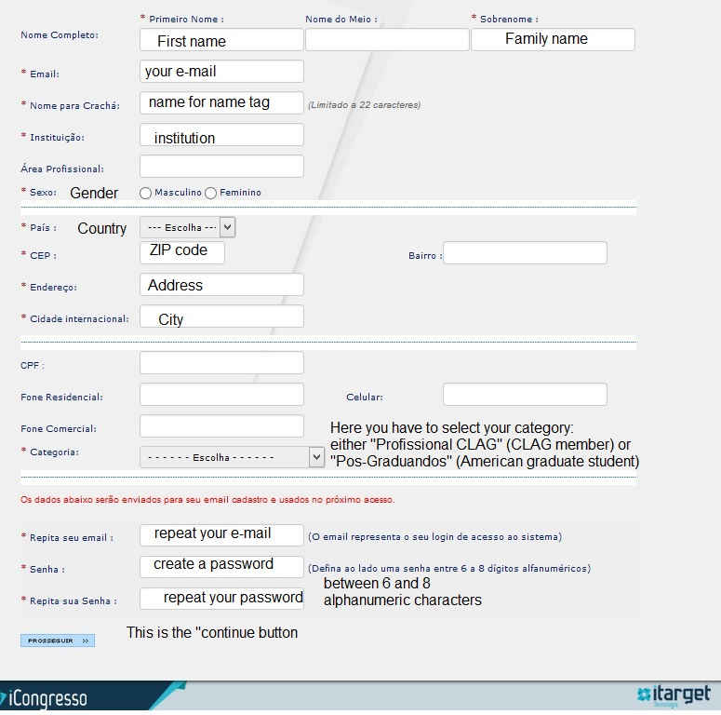
3) By clicking on the PROSSEGUIR BUTTON you will be led to the next screen, where your information is confirmed and you are asked about your credit card details. (Unfortunately, I do not have a screenshot of this page.)
4) You will receive an e-mail by “cieloecommerce” confirming your payment. Please, check all your folders and spam. The message might end up there! (Cielo is the largest Brazilian credit and debit card operator.)
(I have followed all these steps and have already paid my registration fee.)
Please, let me know if you face any kind of problem. I will be more than happy to assist you.
Abraços/Abrazos geográficos,
Jörn Seemann

