Aaron Groth
Robert C. West Ph.D. Award Recipient
Final Research Report: “Property Rights, Land Tenure, and Andean Forest Conservation”
Location of fieldwork: Apurímac (Mancomunidad Saywite-Choquequirao-Ampay); Province of Abancay (districts of Huanipaca, Curahuasi, Tamburco, and San Pedro de Cachora); Province of Andahuaylas (district of Pacobamba).
Fieldwork experiences and achievement of objectives:
I achieved most of my objectives during my first season of dissertation research. I spent a total of three months in Peru, with two months spent in my study area.
In Lima, I met with a number of government institutions and non-governmental organizations and universities.
Initial fieldwork in Apurímac focused upon identifying actors influencing Andean forest conservation, and also developing a typology of livelihoods and land uses. I conducted over 20 interviews with government officials and NGO staff, and met with a number of mayors and community leaders. Coordinating with the local NGO, Centro de Estudios de Desarrollo Social (CEDES), I undertook six community research workshops in the communities of (Antilla, Curahuasi, San Pedro de Cachora, Kuiñalla, Tacmara, and Pacobamba). Workshop participants produced over 20 maps, during a participatory mapping component. The maps revealed areas of pasture, cropland, plantations of pine and eucalyptus, and natural forest remnants. A number of communities asserted their native forests were intangible and that resource use and timber harvest were prohibited. Some communities grew eucalyptus and pine for consumption, while other communities were commercializing eucalyptus to sell to mining companies.
I have a great deal of data and field notes to process.
Productive activities and species composition changes not only along an altitudinal gradient, but also along a horizontal gradient. I hypothesize that that this has to do with not only aspect, but also soils.
Unfortunately, due to time constraints, I did not spend time in Cusco. In another opportunity, I will visit the Centro de Estudios Bartolomé de las Casas and the Universidad Nacional San Antonio Abad de Cusco.
I had hoped to gain familiarity with Gentry transect plots, but I did not achieve this objective. The topography is very steep.
Additional activities:
I made a number of contacts with Professors and students of the Agronomy and Environmental Engineering Departments at the Universidad Tecnológico de los Andes (UTEA) and with the School of Veterinary Medicine and Animal Science (FMVZ) of the Universidad Nacional Michaela Bastides de Apurímac (UNAMBA), both located in the Regional Capital of Abancay. I gave two presentations at UTEA. In July, I presented on Social Aspects of Andean Forests at an International Conference hosted by UNAMBA. With the wildlife study and research group of UNAMBA, I participated in a Conference on Andean Bear (Tremarctos ornatus) conservation, and presented results of research on indigenous resource use in the upper Amazon. My 31st birthday was spent with the rangeland management class of UNAMBA-FMVZ evaluating pasture and teaching students how to use GPS. I hope to maintain these collaborations over multiple field seasons.
Expense Report (award amount: $1,400)
Item – Transportation | cost ($ USD)
Roundtrip air ticket Austin - Lima, Lima – Austin | 885.34
$150/month rent (@ 3 months) | 450
$7/day food/per diem (7*88) | 616
TOTAL | 1951.34

Photos:
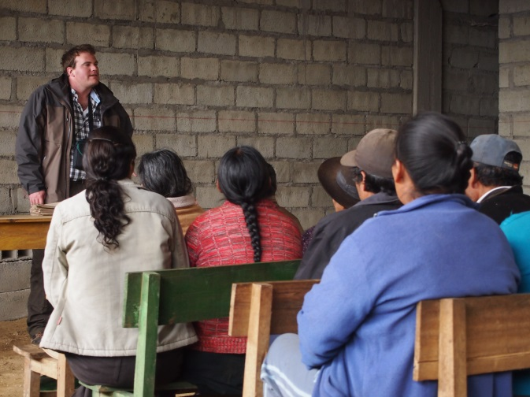 | 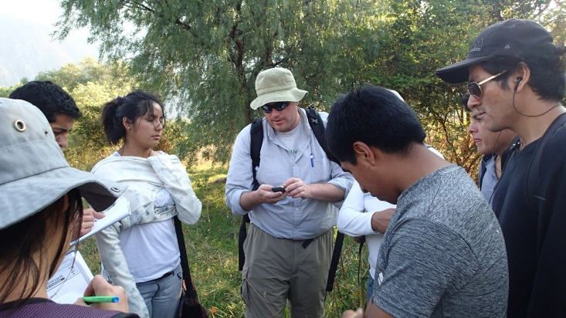
Kuiñalla, Huanipaca district, Abancay, Apurímac, Peru | Teaching GPS to students of rangeland management class UNAMBA-FMVZ

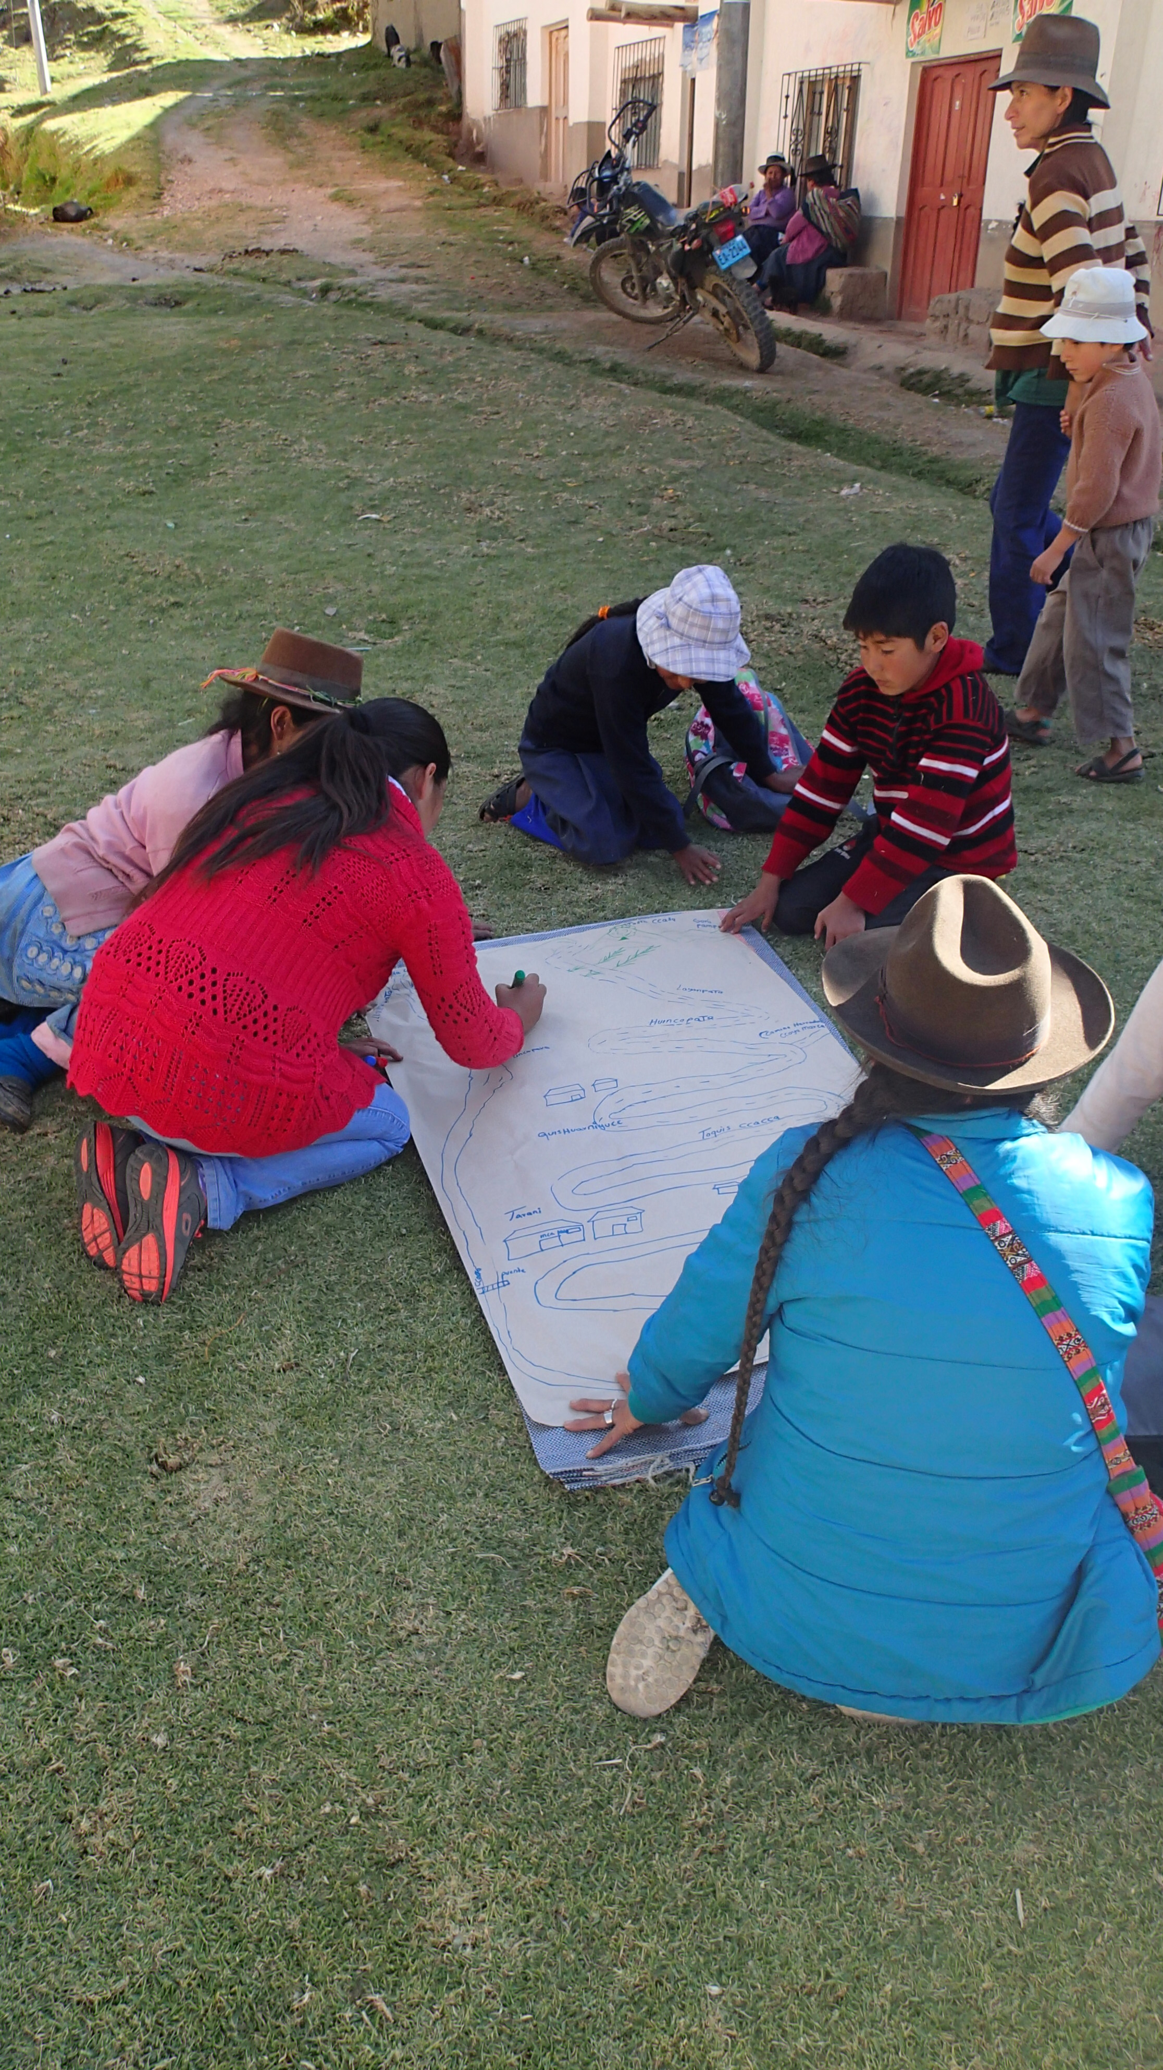
Participatory Mapping in Antilla community, Curahuasi district, Abancay

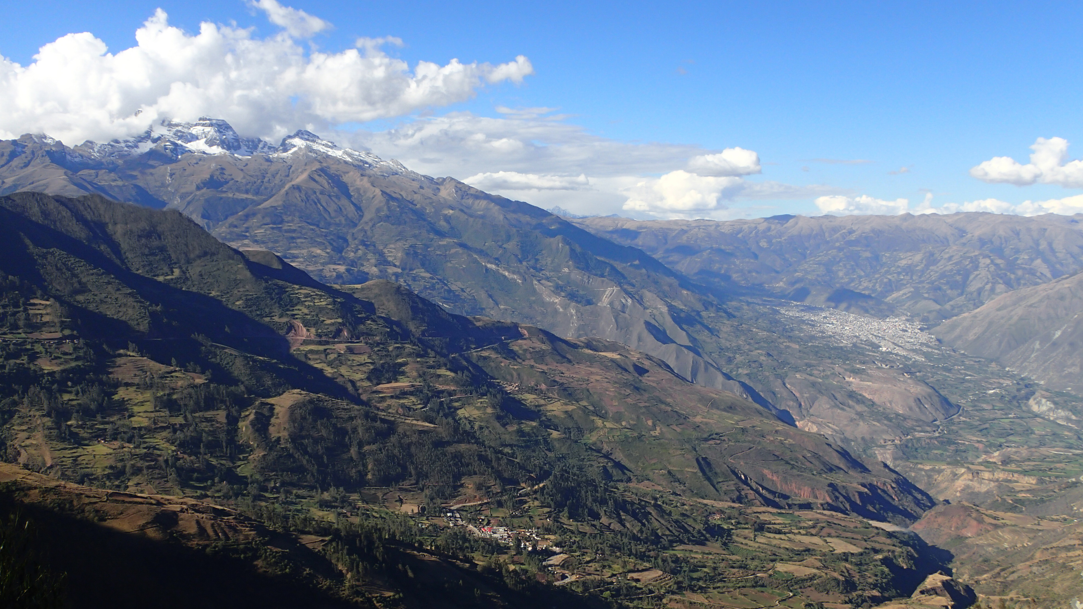
Abancay, below Nevado Ampay (looking across the Pachachaca Canyon from Andahuaylas province).

